**Assignment(1)**

**Class:BBA-III(Sem-V)**

**Subject: Research Methods**

**Topics:**Economics,Difference between cluster and stratified sampling ,compare exploratory and descriptive research

**Submitted To:**

Harman Kaur

Prof.of Management Department

**Ques1:Difference between cluster and stratified sampling?**

**Ans.**

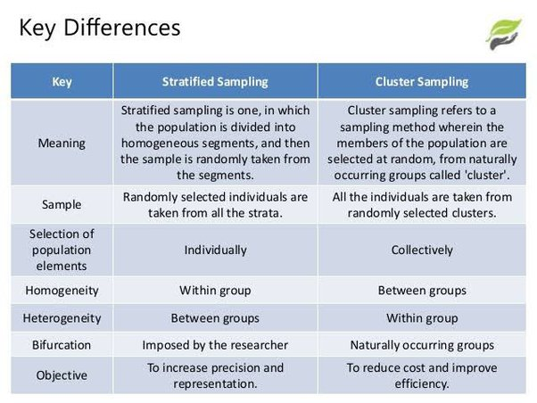

**Ques2:Compare in brief exploratory and descriptive research?**

**Ans.**

